- First of all, you need to complete the implementation of accounting by batches (FIFO/LIFO/Manual), for this you need to automatically fill in the batch according to the existing scheme for the document Transfer of goods. Add missing attributes to the object and elements to the document form. If the batch accounting in the program is FIFO - fill in from the first to the last batch, if LIFO - from the last to the first, if manually - provide filling to a user and add the button "Pick a batch" as it was done for other documents. The amount in the register records should be filled in automatically based on the balance data, just as it works for the document "Sales invoice" and the register "Goods in warehouses".
- Create a print form "List of goods movement" for the document Inventory transfer. You can use the print form wizard for this purpose, but the final appearance of the printed form should be as in the image.
The print form for 2 documents:
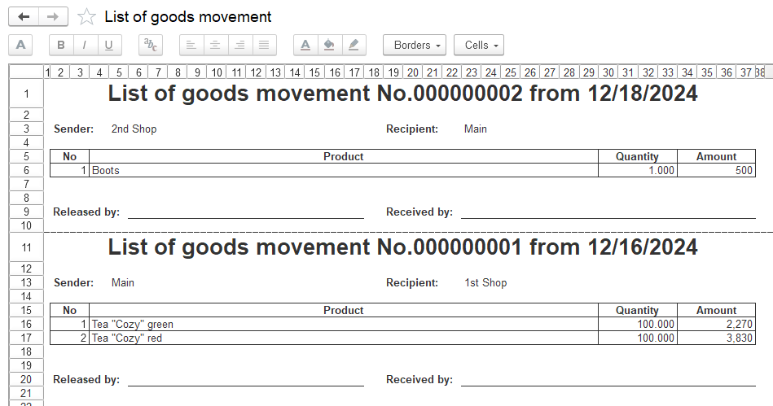
- Create a “Sales by customers” report consisting of 3 levels: 1) Company; 2) Customer; 3) Product. Levels 1 and 2 in the report contain grouped data by the amount and quantity of sales, and are also highlighted in different colors. Include the report in the Sales subsystem. The user should be able to collapse and expand lines in the report by levels 1 and 2. Also provide the user with the ability to specify the report period and filters by companies, customers and products (each filter allows you to select several values). The fields on the report form should contain a clear button for convenient work with filters mechanism.

